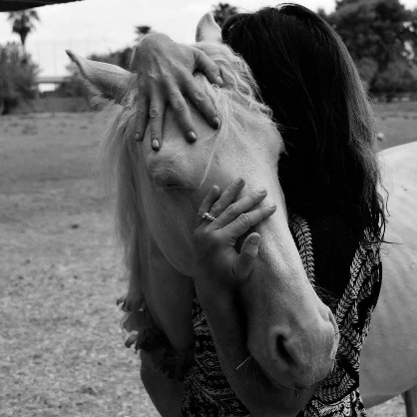
Aimee’s Farm Animal Sanctuary
Liability Release Form
For Farm Visits

I agree for myself and (if applicable) for the members of my family to the following:

1. I agree to observe and obey all posted rules and warnings, and further agree to follow any oral instructions or directions given by Aimee Takaha or agents of Aimee’s Farm Animal Sanctuary.

2. AGE RESTRICTIONS: Volunteers under the age of 14 need to be accompanied by adult supervisors. They are not allowed to be unsupervised while volunteering at Aimees’ Farm Animal Sanctuary. Volunteers age 17 years old and younger agree not to use any power tools or equipment, including but not limited to rototillers, lawn mowers, tractors, or saws. Adult Supervisors accompanying volunteers under the age of 14 years old assume responsibility of compliance

3. I know, recognize and understand that animal behavior is inherently unpredictable and that there are certain inherent risks associated with farm visits, volunteering or being around farm animals. I assume full responsibility for personal injury to myself and (if applicable) my family members, or group members and further release and discharge Aimee’s Farm Animal Sanctuary and Aimee Takaha for/from injury, loss or damage arising out of my or my family’s use of or presence upon the facilities of Aimee’s Farm Animal Sanctuary, whether caused by myself, my family or other third parties.

4. I agree to indemnify and defend Aimee’s Farm Animal Sanctuary against all claims, causes of action, damages, judgments, costs or expenses, including attorney fees and other litigation costs, which may in any way arise from my or my family’s use of or presence upon the facilities of Aimee’s Farm Animal Sanctuary. I also agree to pay for all damages to the facilities of Aimee’s Farm Animal Sanctuary caused by my or my family’s negligent reckless or willful actions.

5. I consent to the participation of myself and child(ren) and/or group following farm visit, tractor rides, volunteering, coming in contact with animals that could be dangerous and agree on behalf of the above persons to all the terms and conditions of this Agreement by signing this LIABILITY RELEASE FORM, I represent that I have legal authority over and custody of said child/children.

IN THE EVENT OF INJURY

6. In the event of injury to the above minor during the above described activities, I give my permission to Aimee’s Farm Animal Sanctuary or to the employees, volunteers or representatives of Aimee’s Farm Animal Sanctuary, to arrange for all necessary medical treatment for which I shall be financially responsible. Additionally, I hereby give permission to have child transported to the closest hospital in event of injury

7. Furthermore, I understand that from time to time, photographs may be taken at Aimee’s Farm Animal Sanctuary, and I hereby give permission to Aimee’s Farm Animal Sanctuary to publish and use such photographs for any lawful purpose.

8. Additionally, I understand that I am allowed to take photographs of the animals during farm visits, any use of such photos will not be used for personal profit without the expressed and written consent of Aimee Takaha.

Any legal or equitable claim that may arise from participation in the above shall be resolved under AZ State Law.

I HEARBY HAVE READ THIS DOCUMENT AND UNDERSTAND IT. I FURTHER UNDERSTAND THAT BY SIGNING THIS RELEASE, I VOLUNTARILY SURRENDER CERTAIN LEGAL RIGHTS.

Signature: ______________________________________ Date: __________________

Print Name: _____________________________________

Address: _______________________________________

Phone: _________________________ Email Address: ______________________

